CprE 381, Computer Organization and

Assembly-Level Programming

Lab 2 Report

Student Name _______Nihaal K Zaheer________

Submit a typeset pdf version of this on Canvas by the due date. Refer to the highlighted language in the lab document for the context of the following questions.

Part 0(Prelab) – Rising edge Synchronous (Asynchronous reset)

[Part 2 (a)] Draw the interface description for the MIPS register file. Which ports do you think are necessary, and how wide (in bits) do they need to be?

There are ports RS,RT which are 5 bits in size, then there is RD, which is read port which is also 5 bits and selects the register to input the 32 bit value, then there are 2 32 bit outputs with 5 bit select lines.

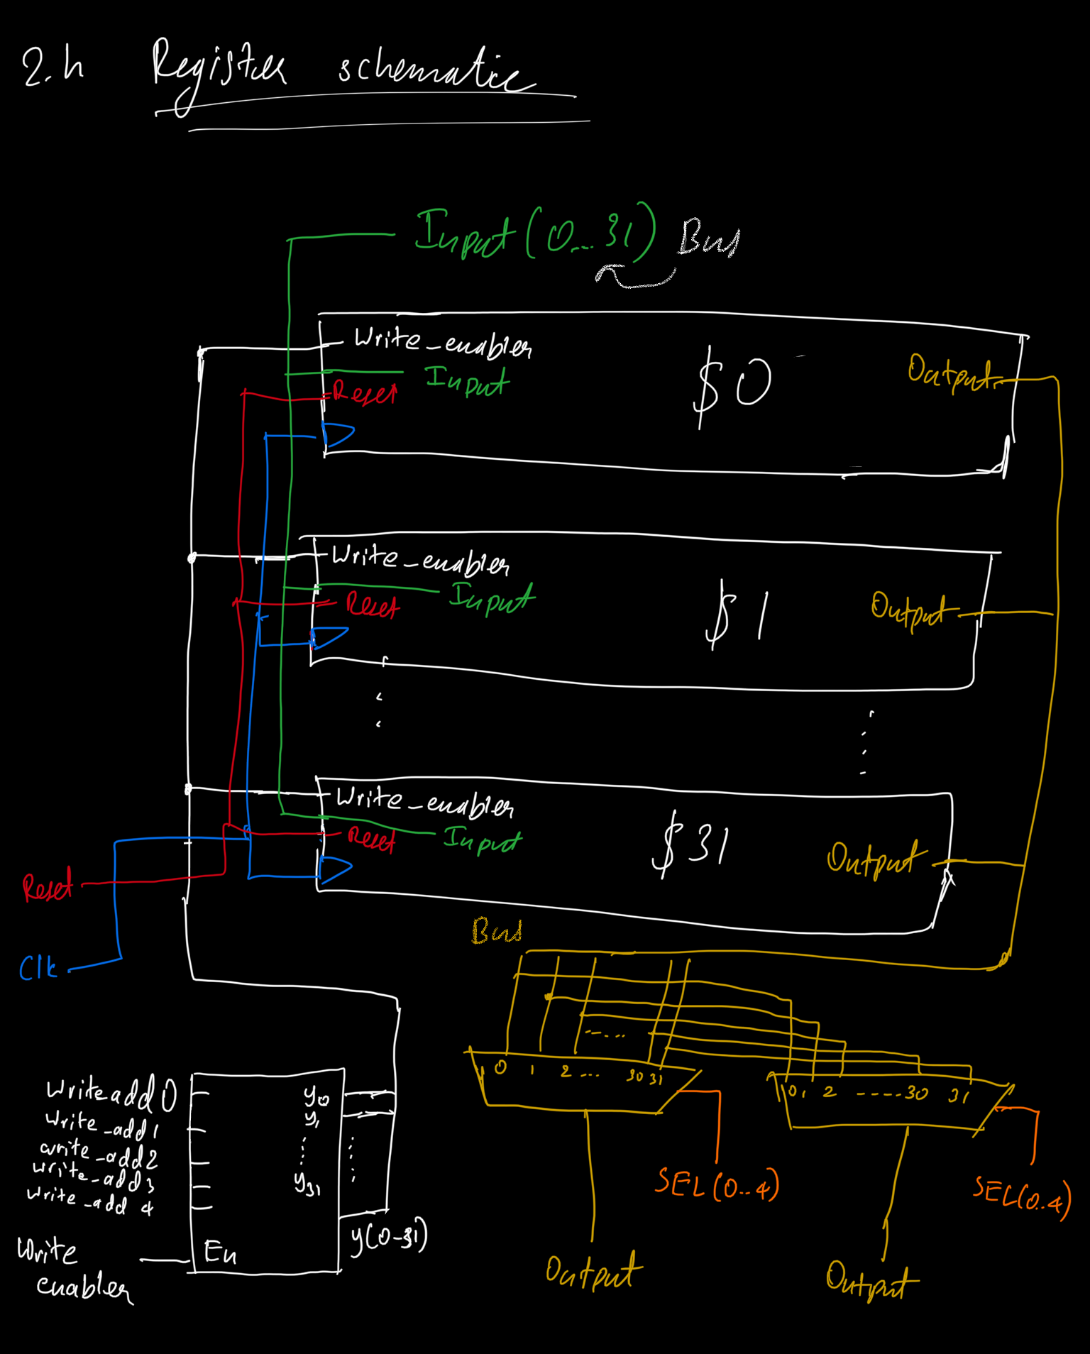
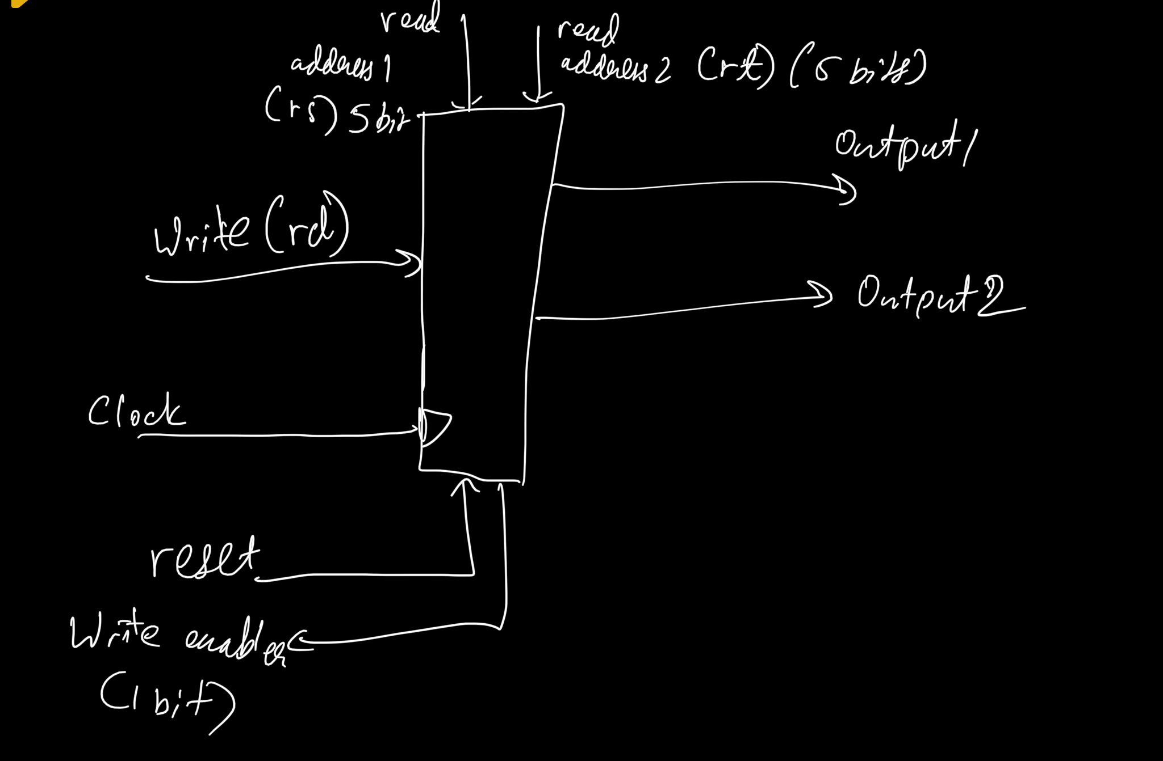

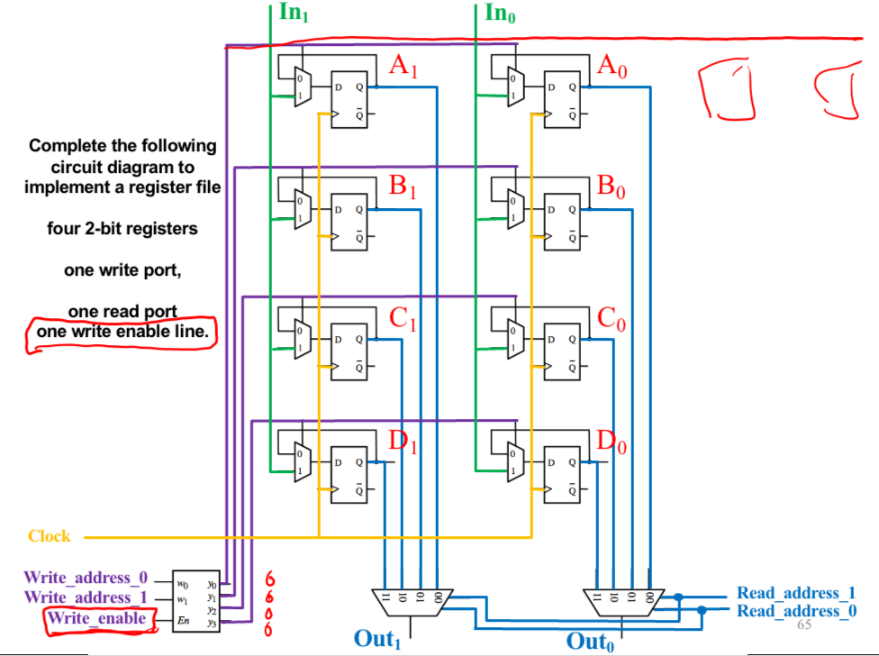
281 Slides

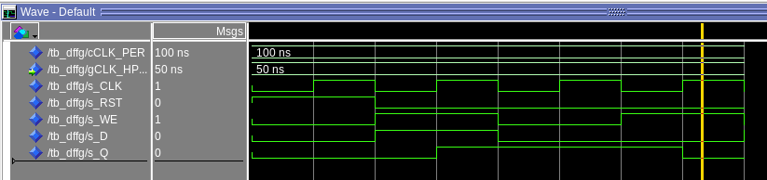
This is the waveform of dffg register, the output changes on +ve edge of the clock and when reset is 0. It latches when WE is set to 0.

[Part 2 (b)] Create an N-bit register using this flip-flop as your basis.
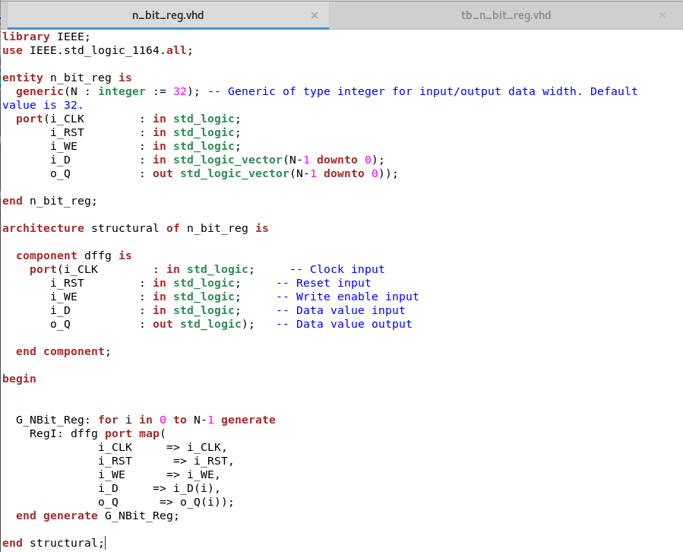

[Part 2 (c)] Waveform.
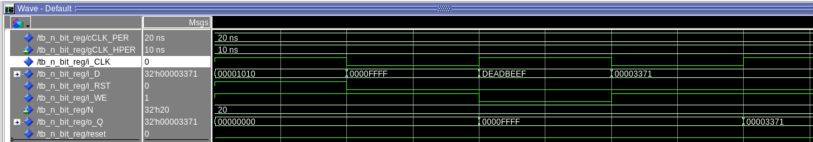

This is correct according to my test cases. The first test case has reset and write set to 1 so no matter the input the output will be 0x00000000. In my second and subsequent test cases I have reset set to 0. My write enabler is set to 1, so this means that the output will be the new input provided when the clock is 1, and the reset is 0 and the write enabler is 0, in this case 0x0000FFFF. In the last test case I have set the write enabler to 1 and give the input as 0x00003371, which we see as the output on the next positive edge.

[Part 2 (d)] What type of decoder would be required by the MIPS register file and why?

Since there are 32 registers, so we will need 32 outputs from the register. Therefore there should be 5 inputs to the decoder (2^5 = 32). So the type of the decoder would be a 5-to-32 Decoder

[Part 2 (e)] Waveform.

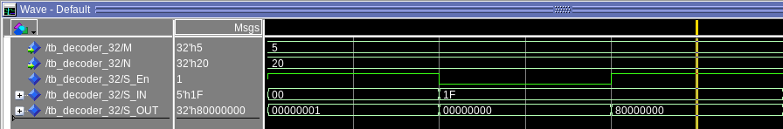
S_OUT shows the values in decoder_32 that corresponds to S_IN when enabler is set to 1.

[Part 2 (f)] In your write-up, describe and defend the design you intend on implementing for the next part.
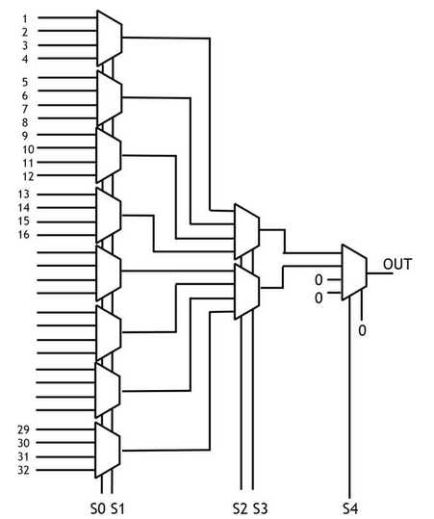
I used dataflow for implementing mux32-to-1, I used this design since it is the easiest to implement. Hardcoding the Input values to the select lines will give a unique output for each of the 32 cases.
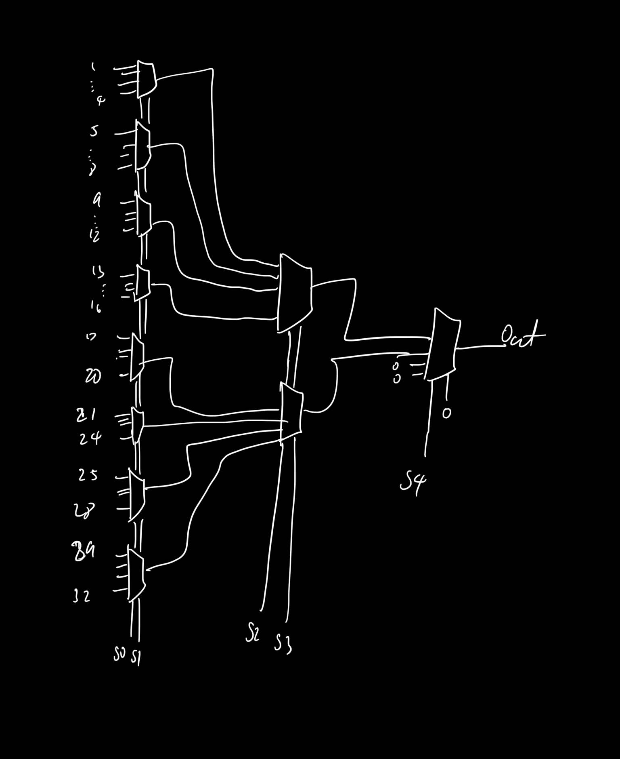
[Part 2 (g)] Waveform.
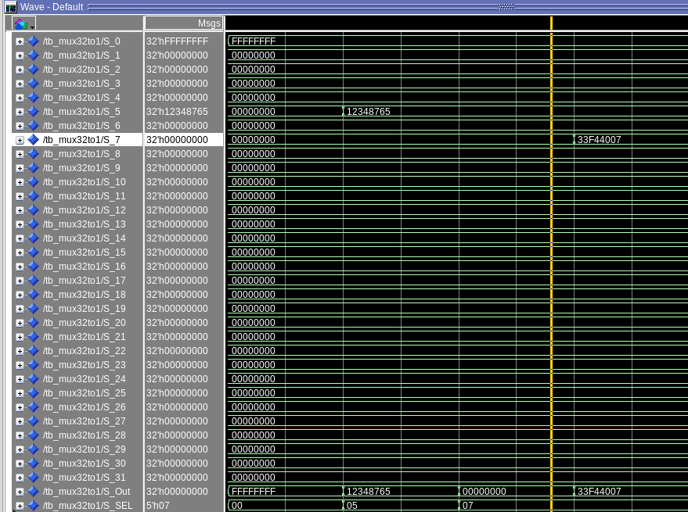

There are 4 test cases, the first is writing ‘FFFFFFFF’ to S_0 and giving 00000 to the select line, so we get the same as the output, the same goes for the next test case where we store values in S_5. In test case 3 we store ‘12348765’ in S_5 but the select line calls S_7 so it return 0, in the last test case, we store the value in S_7 and the select line calls S_7 so we see the corresponding output.

[Part 2 (h)] Draw a (simplified) schematic for the MIPS register file, using the same top-level interface ports as in your solution describe above and using only the register, decoder, and mux VHDL components you have created.

[Part 2 (i)] Waveform.

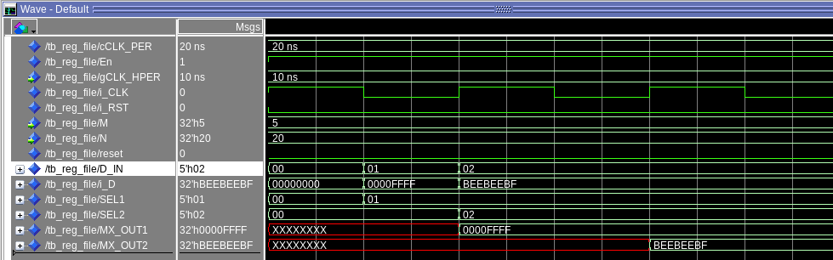

D_IN is the destination resgister or the adress of where to write to. I_D is the data written to the register. SEL1 and SEL2 are the 2 select lines for the MUXs or Read1 and Read2, Based on SEL1 and SEL2, we get MX_OUT1 and MX_OUT2.

[Part 3 (b)] Draw a symbol for this MIPS-like datapath.

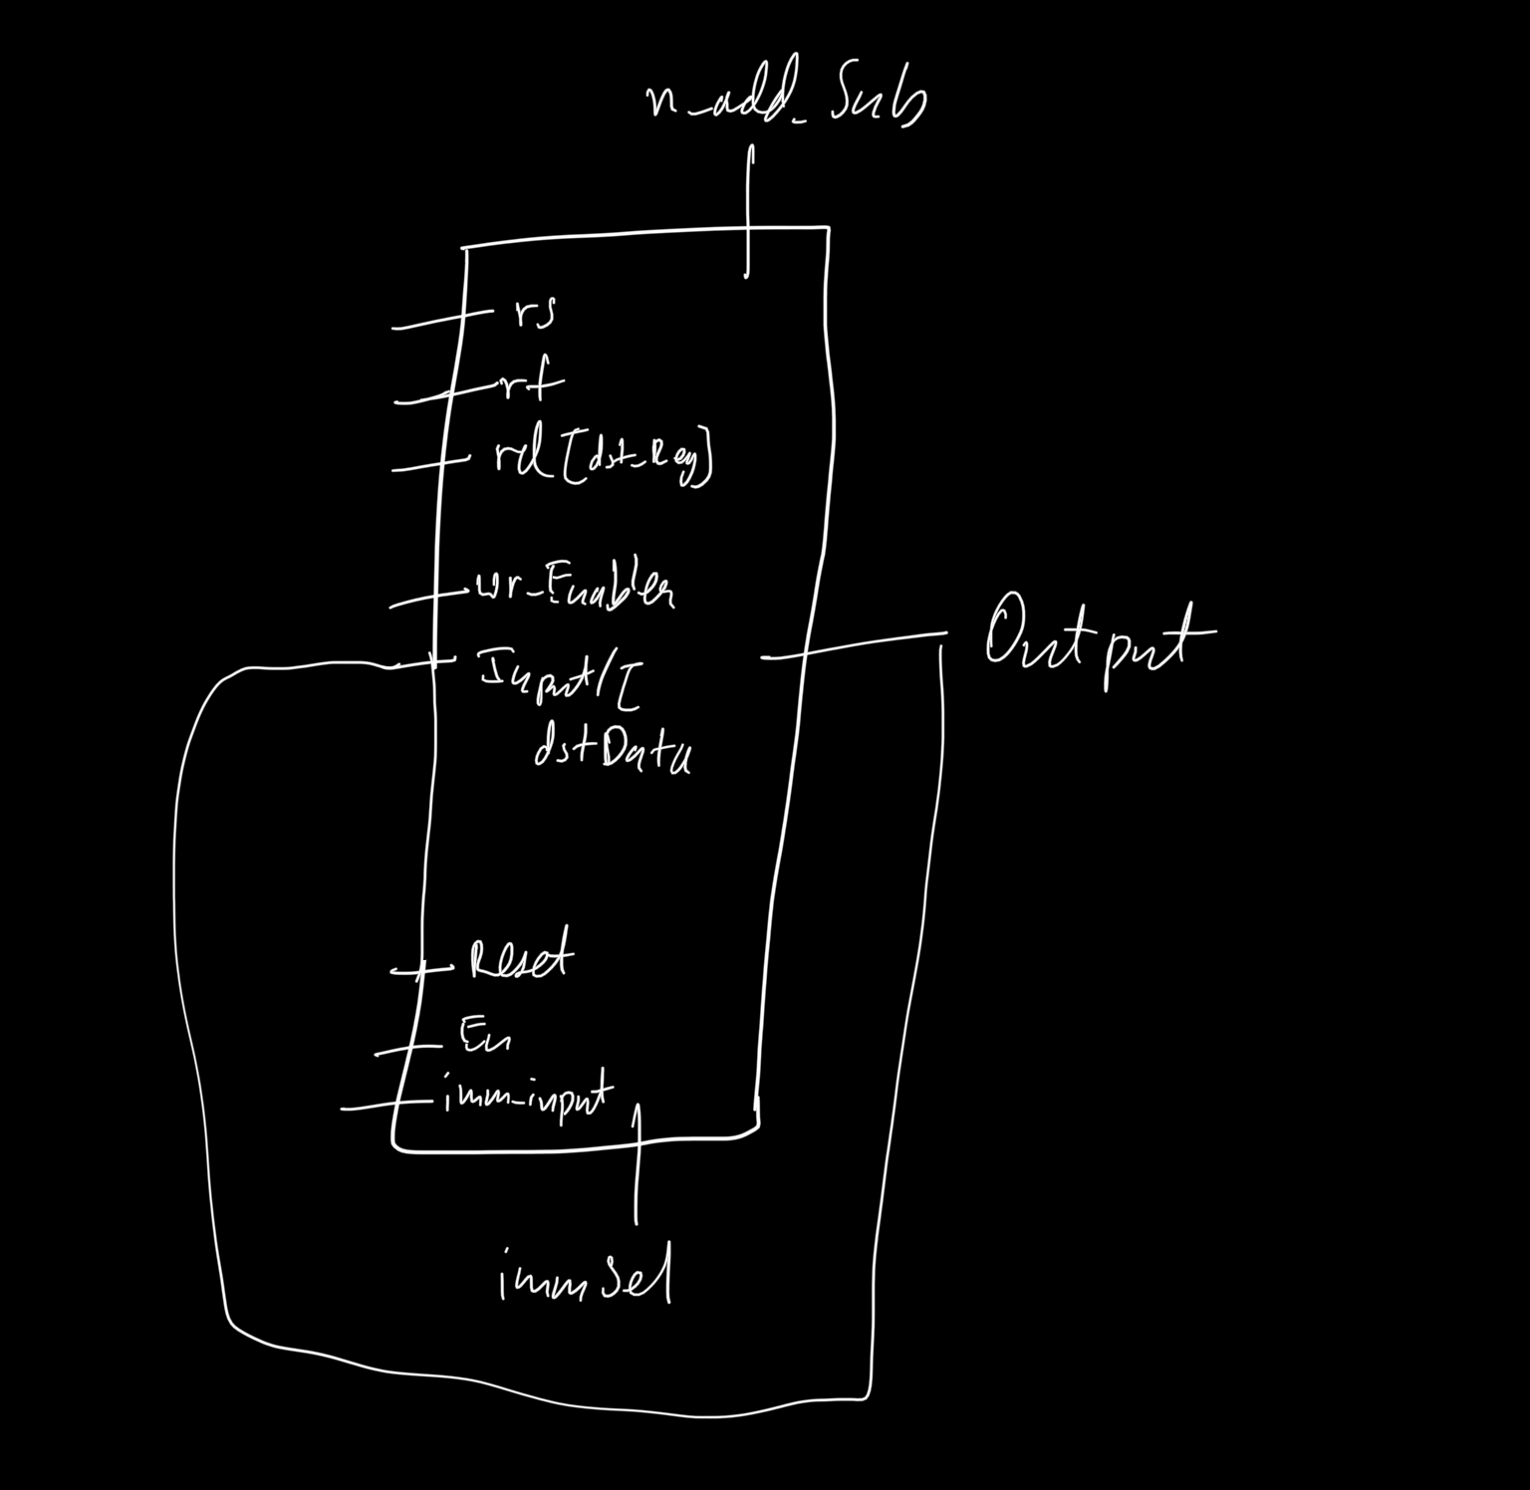

The waveform verifies the design. First we load 0x0000000 to register 00, with reset set to 0 and enabler set to 1, the select lines for both the registers are set to 1, and this value changes on the next clock cycle when there is a rising edge.

[Part 3 (c)] Draw a schematic of the simplified MIPS processor datapath consisting only of the component described in part (a) and the register file from problem (1).

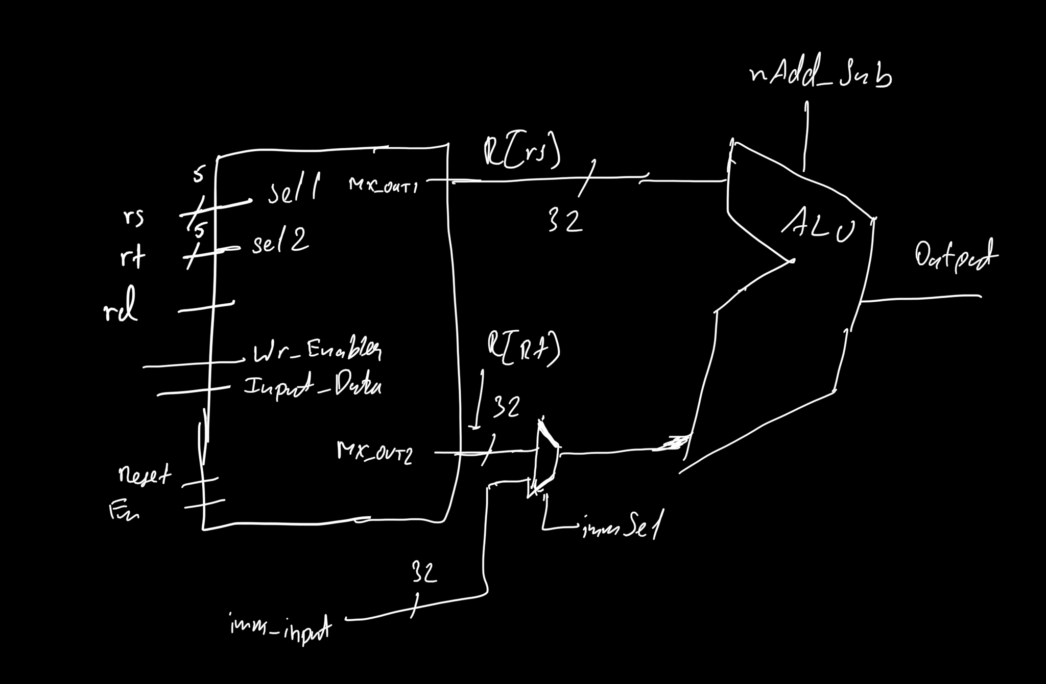

[Part 3 (d)] Include in your report waveform screenshots that demonstrate your properly functioning design. Annotate what the final register file state should be.

The below are screenshots of MUX values after we do addi and sub. These are correct and in accordance with what we calculate by hand or in a mars simulator.
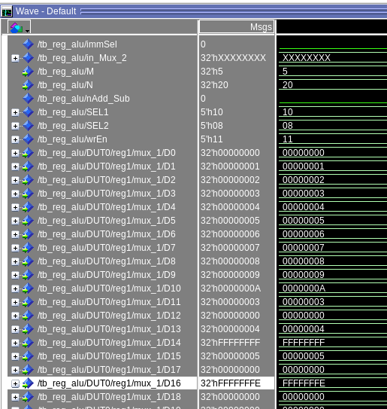
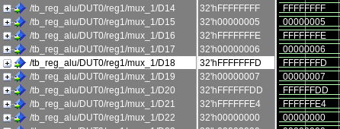

These are the values stored in the MUXs after running the testbench, it verifies the design according to the test cases given.

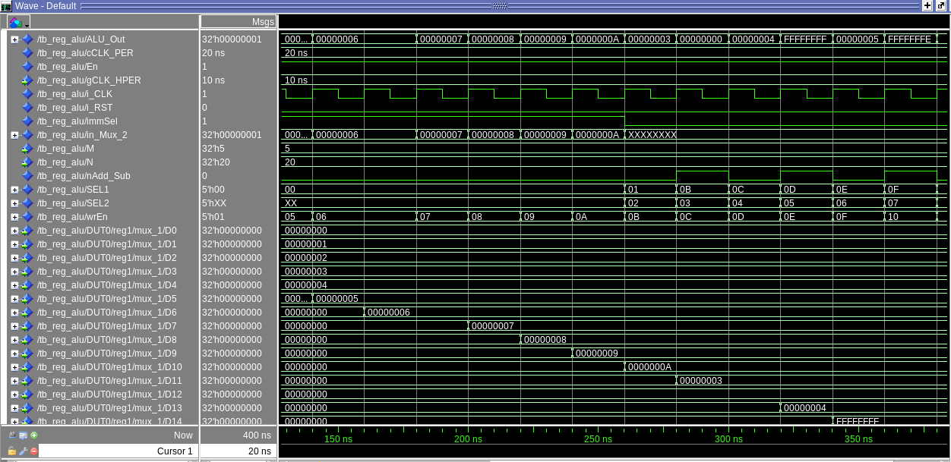
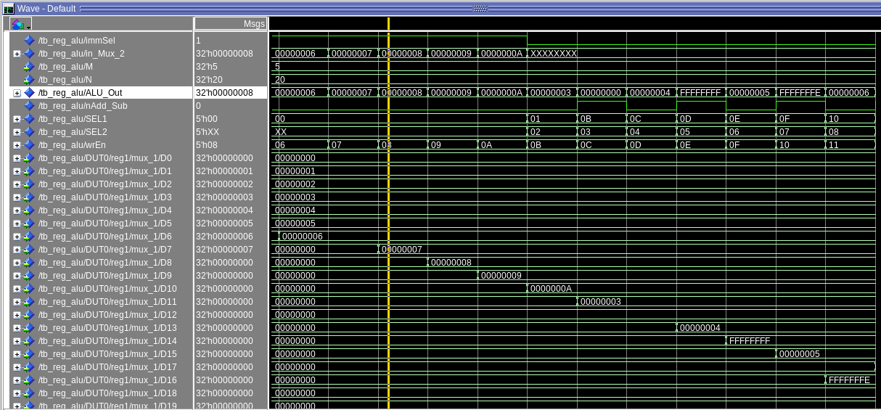

[Part 4 (a)] Read through the mem.vhd file, and based on your understanding of the VHDL implementation, provide a 2-3 sentence description of each of the individual ports (both generic and regular).
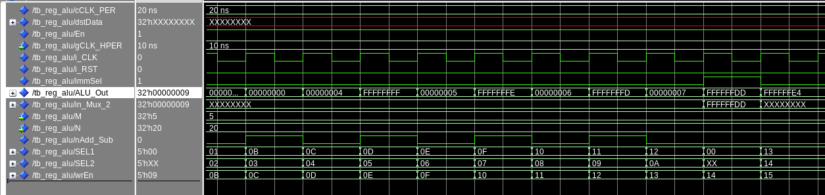
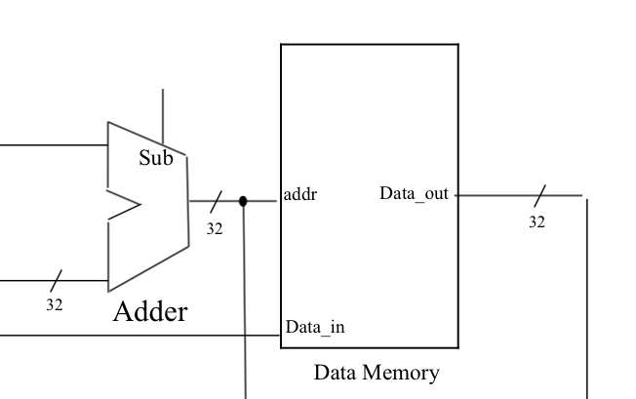

The entity mem has 2 generics, DATA_WIDTH which is 32 bits wide and ADDR_WIDTH which is 10 bits wide. There 5 ports, 4 inputs and 1 output. There is also a defined as signal ram : memory_t. Then finally within the begin statements there are nested conditions which check for the rising edge of the clock as well as if ‘we’ = 1.
This basically storing data and instructions in a 2D array. There is a subtype word_t which is 32 bits wide. We also have a type memory_t which is a 2D array 10x10 wide.
The mem.vhd file has a structure for a memory or a basic ram, and defines how data is stored. So instructions and values from the register that are passed through the ALU is stored in the memory for quick and easy access. The output of the memory is then re-directed as the input of the register file

[Part 4 (c)] Waveforms.

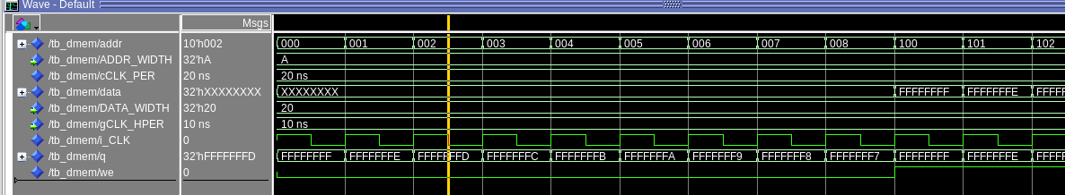
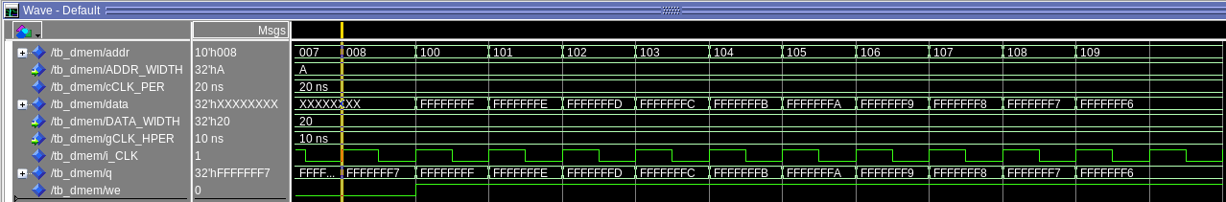
These are the values from the file dmem.hex. The first 10 values are inputted from the hex file, the next 10 values are written from the address 0x100 from the testbench

[Part 5 (a)] What are the MIPS instructions that require some value to be sign extended? What are the MIPS instructions that require some value to be zero extended?

Sign Extension: addi, addiu, lbu, lh, lw, slti, sltiu, sb, sc
Zero Extension: andi, ori, sll, srl

[Part 5 (b)] what are the different 16-bit to 32-bit “extender” components that would be required by a MIPS processor implementation?

Sign and zero Extension ares are the 2 type of extender components that would be required by a MIPS processor.

[Part 5 (d)] Waveform.

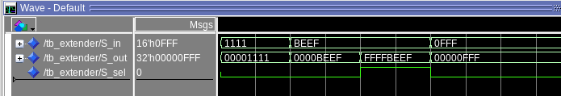
When the select line for the extender is 0, it gets 0 extended as shown in 1st and 2nd case, when select line is 1 and leading bit is 1, it get sign extended, that is all the extended bits will be 1(case 3). But if select line is 1 and leading but is, then extended bits will all be 0(case 4).

[Part 6 (a)] what control signals will need to be added to the simple processor from part 2? How do these control signals correspond to the ports on the mem.vhd component analyzed in part 3?

We will need an output signal from the data memory which then goes through a 2to1 MUX, this mux will decided whether the signal should go back to the register file or back to the memory, we will also have 32 bit extender to extend the 16 bit values to sign extend or zero extend as per need.

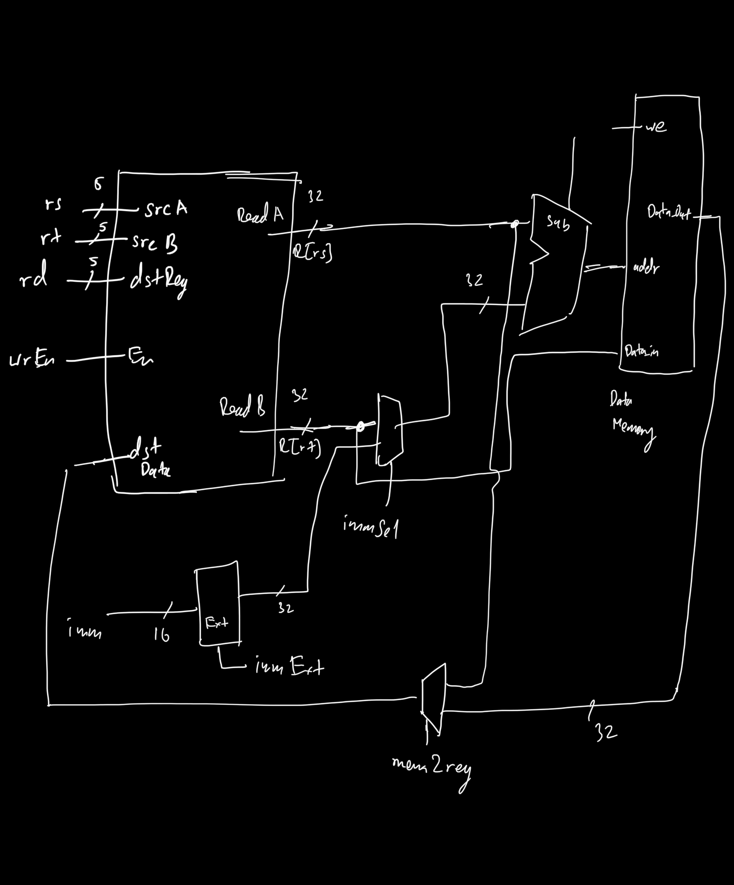

[Part 6 (b)] Draw a schematic of a simplified MIPS processor consisting only of the base components used in part 2, the extender component described in part 4, and the data memory from part 3.
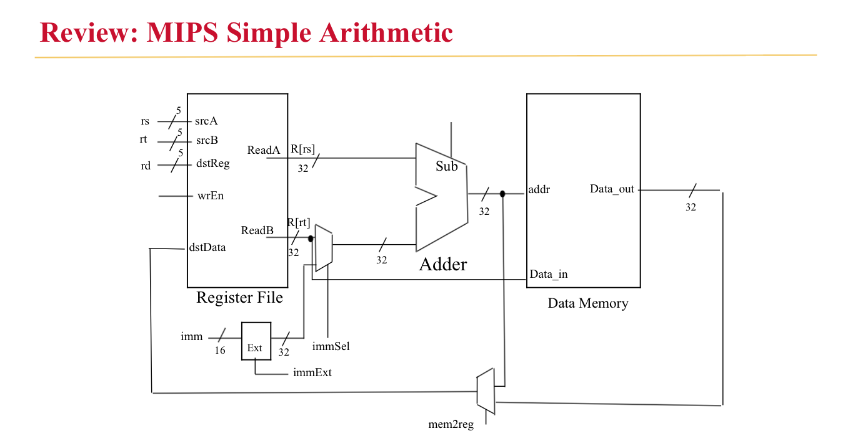

[Part 6 (c)] Waveform.

“mem load -infile dmem2.hex -format hex /tb_mips/mips_d/memory1/ram” the command I run to load data from dmem2.hex into memory.

The below screenshots show the simulations for a simple mips processor with a register file, ALU, and memory. All the ports are in accordance to the schematic above. A few screenshots below show data in the registers and this is the data that we expect to be stored in the registers (D0, D1, D2, D3). This proves that our addi, add, and lw functions work as expected. Below are also screenshots of data within the ram, we see 0 to 29 are values stored from the file dmem2.hex, we then also see data written at 256th position in the RAM and several other data being written with an offset of 4, we also see value at 512. This proves that our sw function works correctly

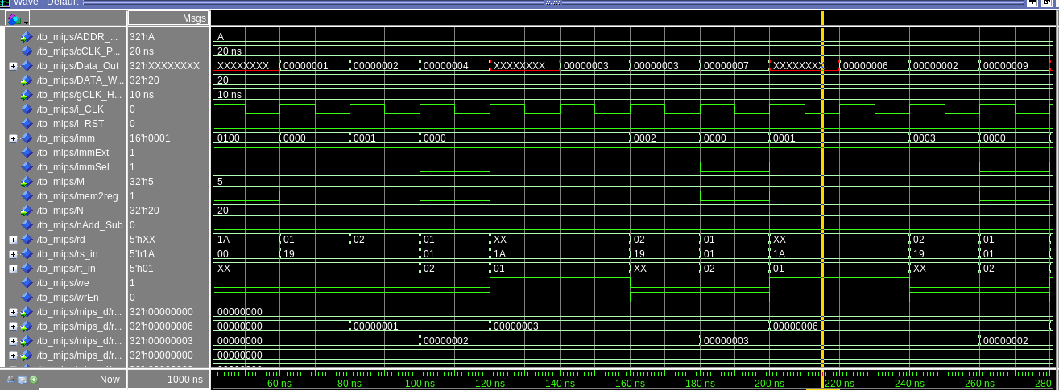

Register Data

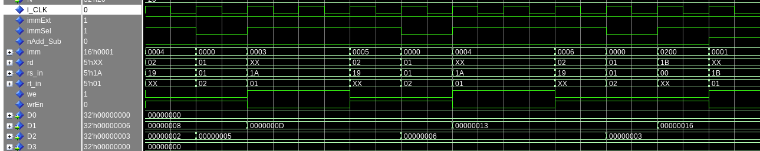
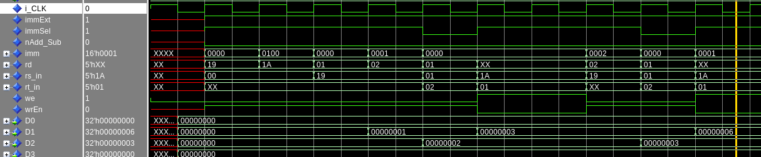

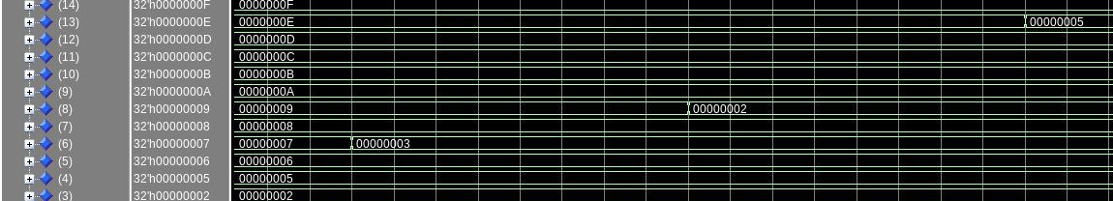
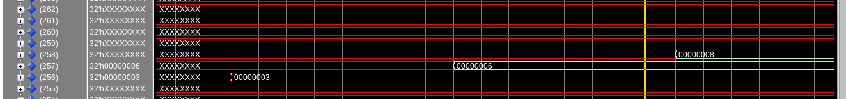
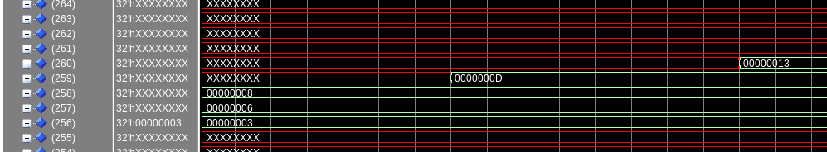
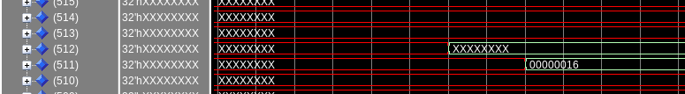
RAM Screenshots

